**Experimental Determination of Planck's Constant Using the Threshold Voltage of Light Emitting Diodes**

**AIM**

To determine Planck's constant by measurement of the threshold voltage of various coloured LEDs.

**BACKGROUND**

Incandescent globes produce light due to thermal emission of electromagnetic waves. Due to the wide variety of energies of the particles, these globes produce all frequencies of visible (and non-visible) light. Incandescent globes can be approximated as a black body and so the colour of these globes depends on the temperature of the filament; the cooler the filament, the yellower the light appears and the hotter the filament the whiter the light appears.

**L**ight **e**mitting **d**iodes (LED) however produce only one wavelength of light. LED light is produced by the movement of electrons in semiconductors and the type of semiconductors determines which wavelength is produced. In simple terms, an EMF source gives energy to electrons and these electrons lose energy in the LED semiconductor when they cause the emission of a photon of light. The energy of the light emitted by an LED can be calculated from its wavelength:

$E=hf=\frac{hc}{λ}$ (1)

The energy of the electrons passing through an LED can be calculated from the potential difference across the LED:

$E=qV$ (2)

Each time an electron emits a photon, it loses the energy calculated by formula (1). The energy of the electrons in the LED as calculated by formula (2) may be greater than the energy of the photons the electrons emit. The electrons lose their left over energy as heat due to the LED's resistance. An LED has a **threshold voltage ($V_{T}$)**. This is the minimum voltage for an LED to turn on. At the threshold voltage the electrons have only just enough energy to emit a photon and so formula (1) can be equated with formula (2):

$$\frac{hc}{λ}=qV_{T}$$

$∴ V_{T}=\frac{hc}{qλ}$ (3)

**HOW TO DETERMINE THE THRESHOLD VOLTAGE**

By taking measurements of a range of voltages and currents through an LED, the V-I characteristics of the LED can be determined. LEDs have a V-I characteristic similar to the one shown below.

V

I

Linear light emitting region

No light produced

The exact behaviours of semiconductors are beyond the scope of this experiment, but in order to determine a reasonable threshold voltage it is best to extrapolate a line of best fit for the linear portion of the V-I characteristic of an LED. The intercept of this line with the voltage axis is the threshold voltage. See the graph below as an example.

V

I

Threshold Voltage

**EQUIPMENT**

* Power Pack
* 2 x Digital Multimeter
* 300 Ω Resistor
* 100 Ω Resistor
* 7 x Electrical Wire (alligator clips)
* Various Coloured LEDs; red, green, yellow and orange (blue if available)

**Task 1 - PROCEDURE**

Prepare a procedure that will allow for plotting the relationship between the threshold voltage ($V_{T}$) and the wavelength of the LED light ($λ$) on a graph. The equipment above will be supplied. Other equipment can be requested.

Hints:

* Produce V-I profile of one LED to determine $V_{T}$ for that LED colour. Design a circuit that will allow you to plot this V-I profile. Repeat for all colours.
* LED wavelengths come from the manufacturer but common colours can be researched
* **The LED will be damaged if its voltage is larger than 3.00 V or the current is larger than 50.0 mA**. If this is the case, turn off the circuit and increase the amount of resistance in series with the LED.

LEDs have a polarity.

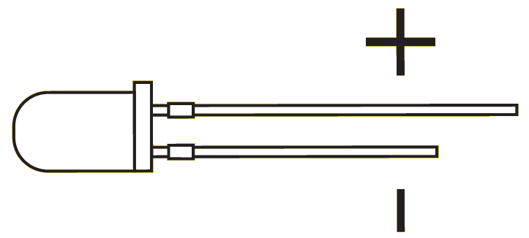

Attach the positive end of the LED to the positive side of the EMF source.

**Task 2 - ANALYSIS**

1. Plot the V-I characteristic for each LED. With careful choice of scale it may be possible to show all LED profiles on a single set of axes. The use of spreadsheet software such as Excel may speed up the process. Determine the threshold voltage and record it against the wavelength of each LED.
2. Estimate the uncertainty of the threshold voltages and the wavelengths of the LEDs. This may be due to the precision of the equipment, uncertainty in researched values or method of calculation. Explain the reason for your choice of uncertainty and record these values with the table of threshold voltage and wavelength values.
3. Produce a **linear** graph of the **threshold voltage against the wavelength** of the LED. Refer to formula (3) in the background section for clues to determine how to linearise the data. Include error bars on your graph based on the uncertainties in step (2)
4. By referring to the axes of the graph produced in step 2 of the analysis and formula (3) from the background section, state the physical quantity represented by the gradient of the graph.
5. Calculate the gradient of the graph. Include the units.
6. Calculate Plank's constant using the gradient of the graph.

**Task 3 - CONCLUSION**

1. By calculating the percentage difference, compare your determination of Planck's constant with the currently accepted value.
2. State the major sources of error in your experiment.
3. Suggest improvements that may aid in increasing the accuracy and precision of the experimental determination of Planck's constant using the threshold voltage of LEDs.

**REFLECTING UPON YOUR LEARNING**

On the atomic level, electromagnetic radiation is emitted or absorbed in discrete packets called photons. The energy of a photon is proportional to its frequency. The constant of proportionality, Planck’s constant, can be determined experimentally using the photoelectric effect and the threshold voltage of coloured LEDs

The above statement is in the Syllabus for Physics Unit 4. Using the background section, the experimental procedure and your analysis of the results as a guide, create a summary of key notes to help you make the important links between Planck's constant and the threshold voltage of LEDs.

**Task 4 – In Class Validation**

You will be assessed on this investigation in an in-class test. Second hand data will be provided. Be familiar with your planning, the derivation of the important relationships and the steps to analyse the raw results and the error analysis.

Teacher Hint:

An effective way to get a good range of voltages across the LED is to have a 50 Ohm resistor in series with rheostat and connect the LED in parallel with the 50 Ohm. Changing rheostat resistance gives a good range of voltages across parallel branches of 50 Ohm/ LED.